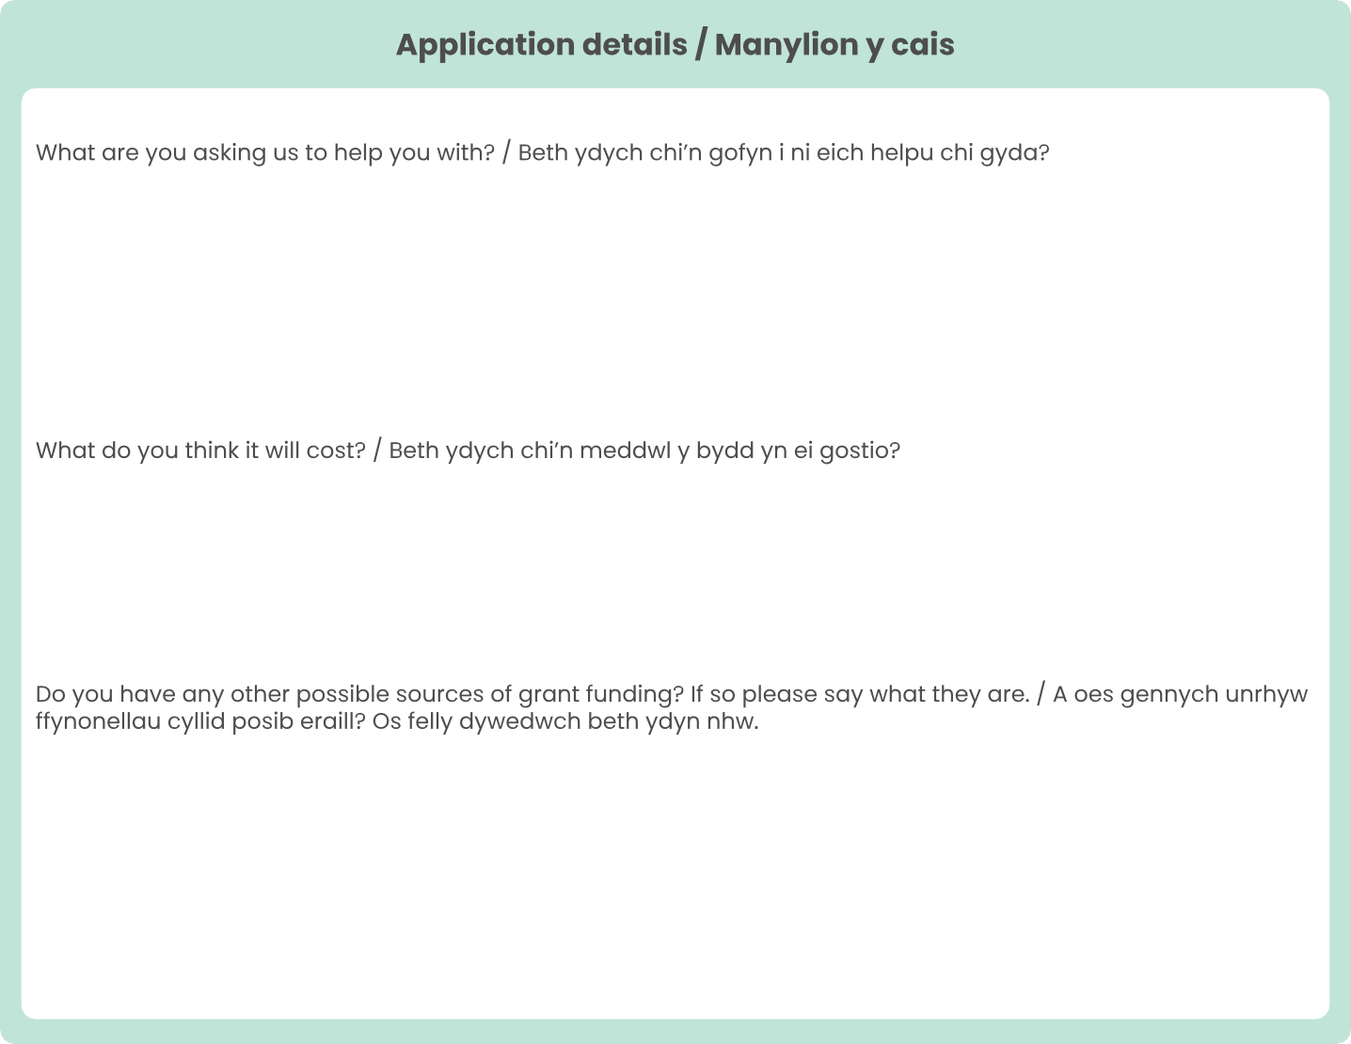




Name here
Date here
Address here
Postcode here
Email address here
Phone number here
Personal details / Manylion personol
Name / Enw
Date of birth / Dyddiad geni
Address / Cyfeiriad
Post code / Côd post
Email / E-bost
Phone / Ffôn
Respond here
Respond here
Respond here
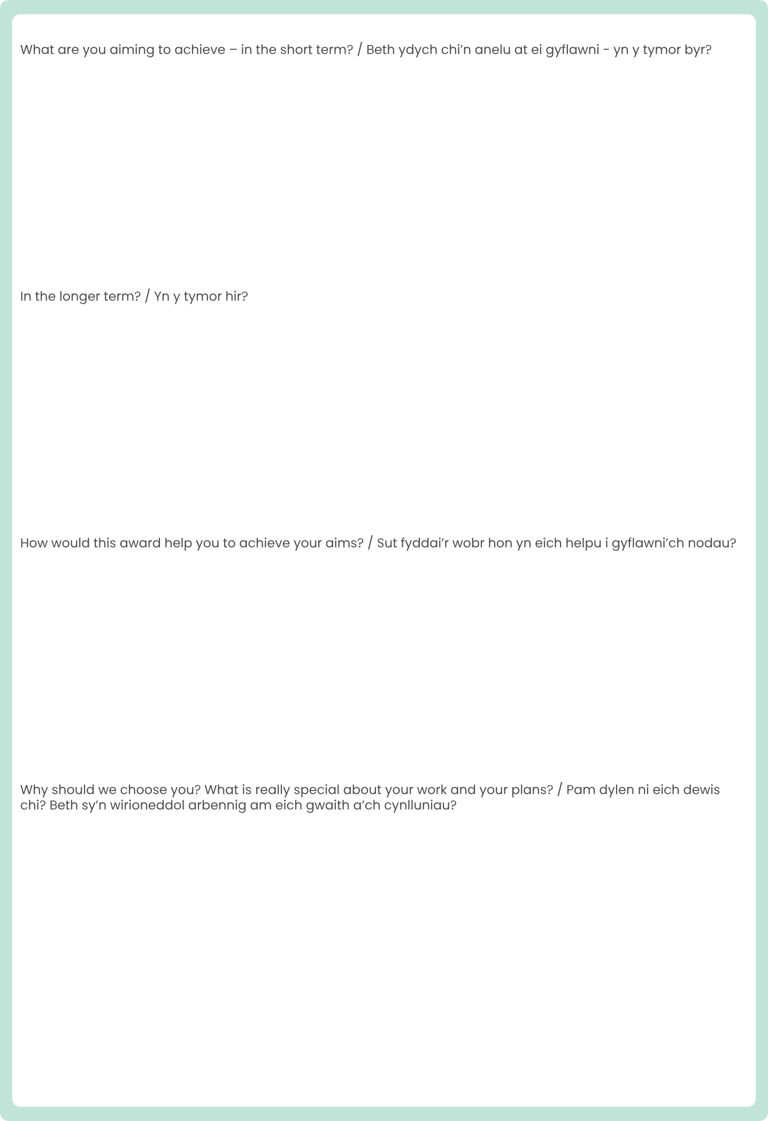
Respond here
Respond here
Respond here
Respond here


Respond here

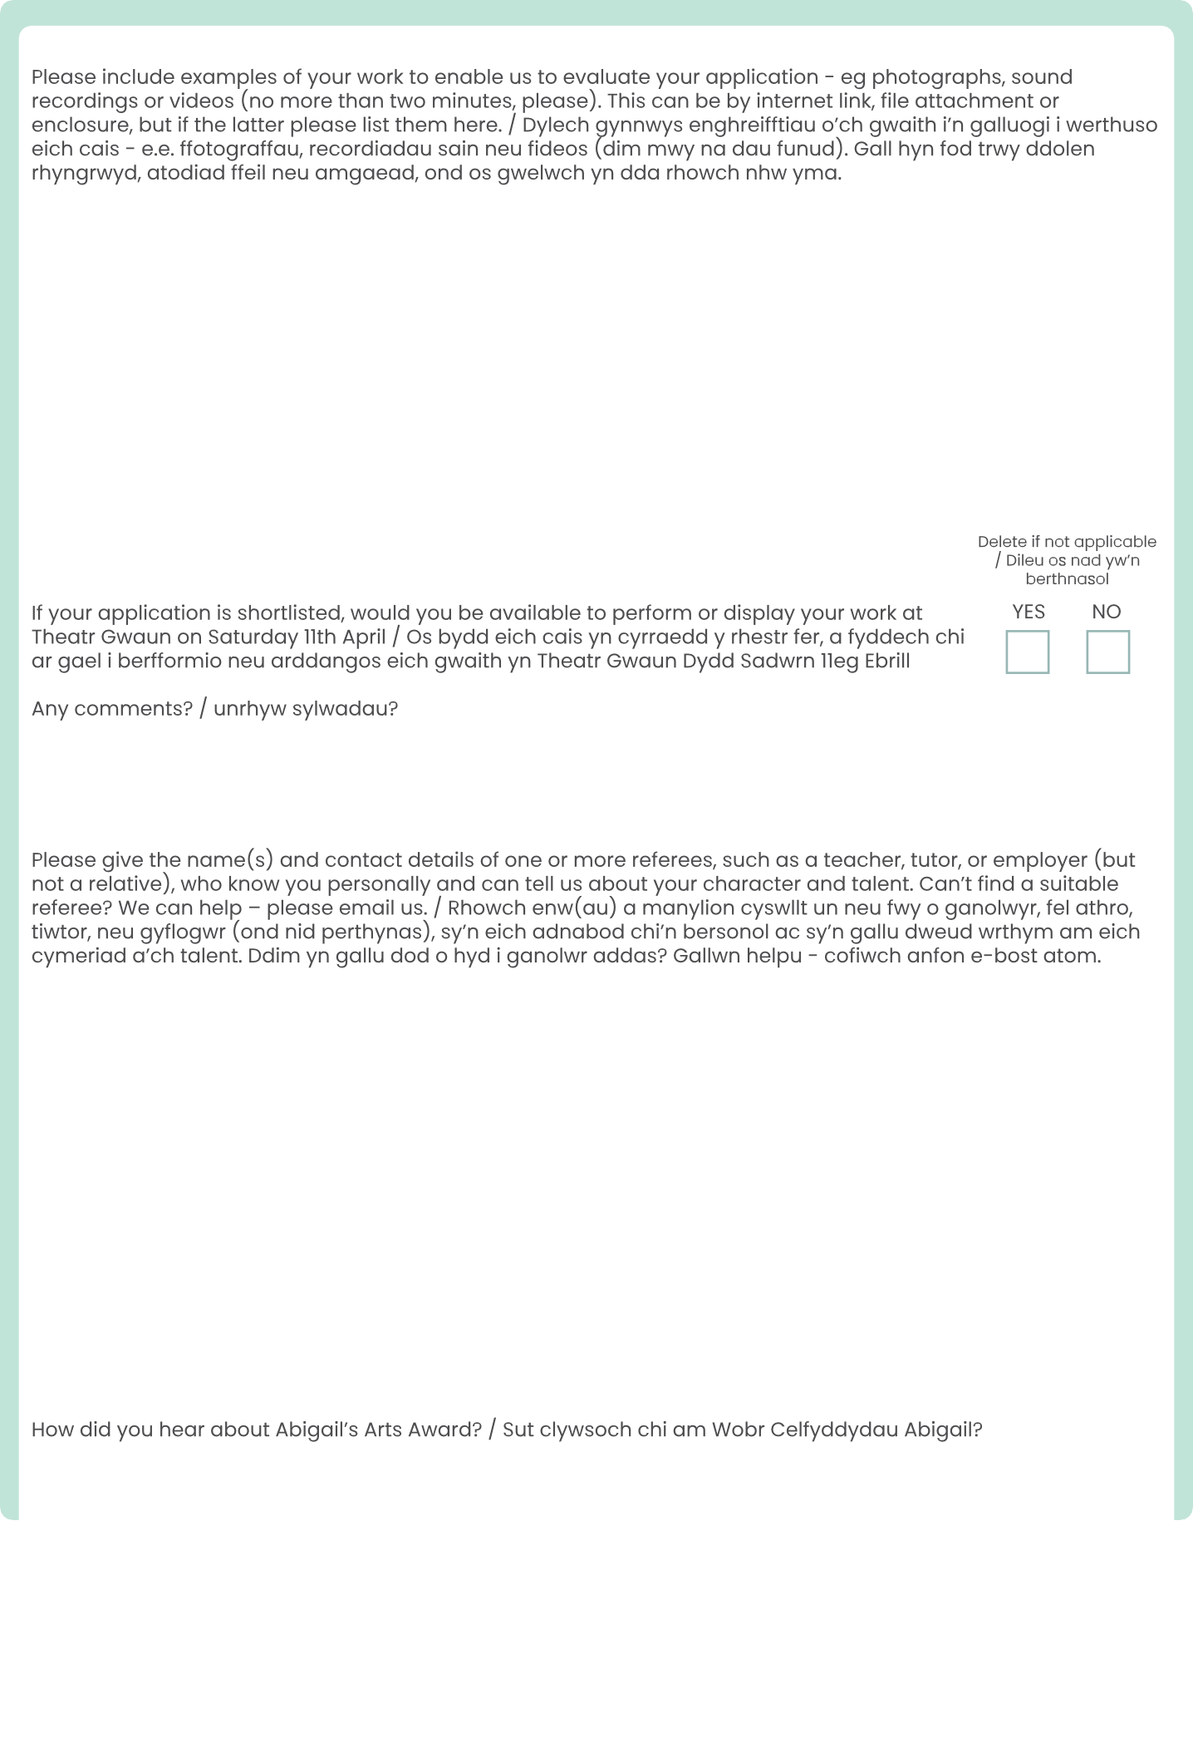
Respond here
Respond here
Respond here
Respond here
Y
N

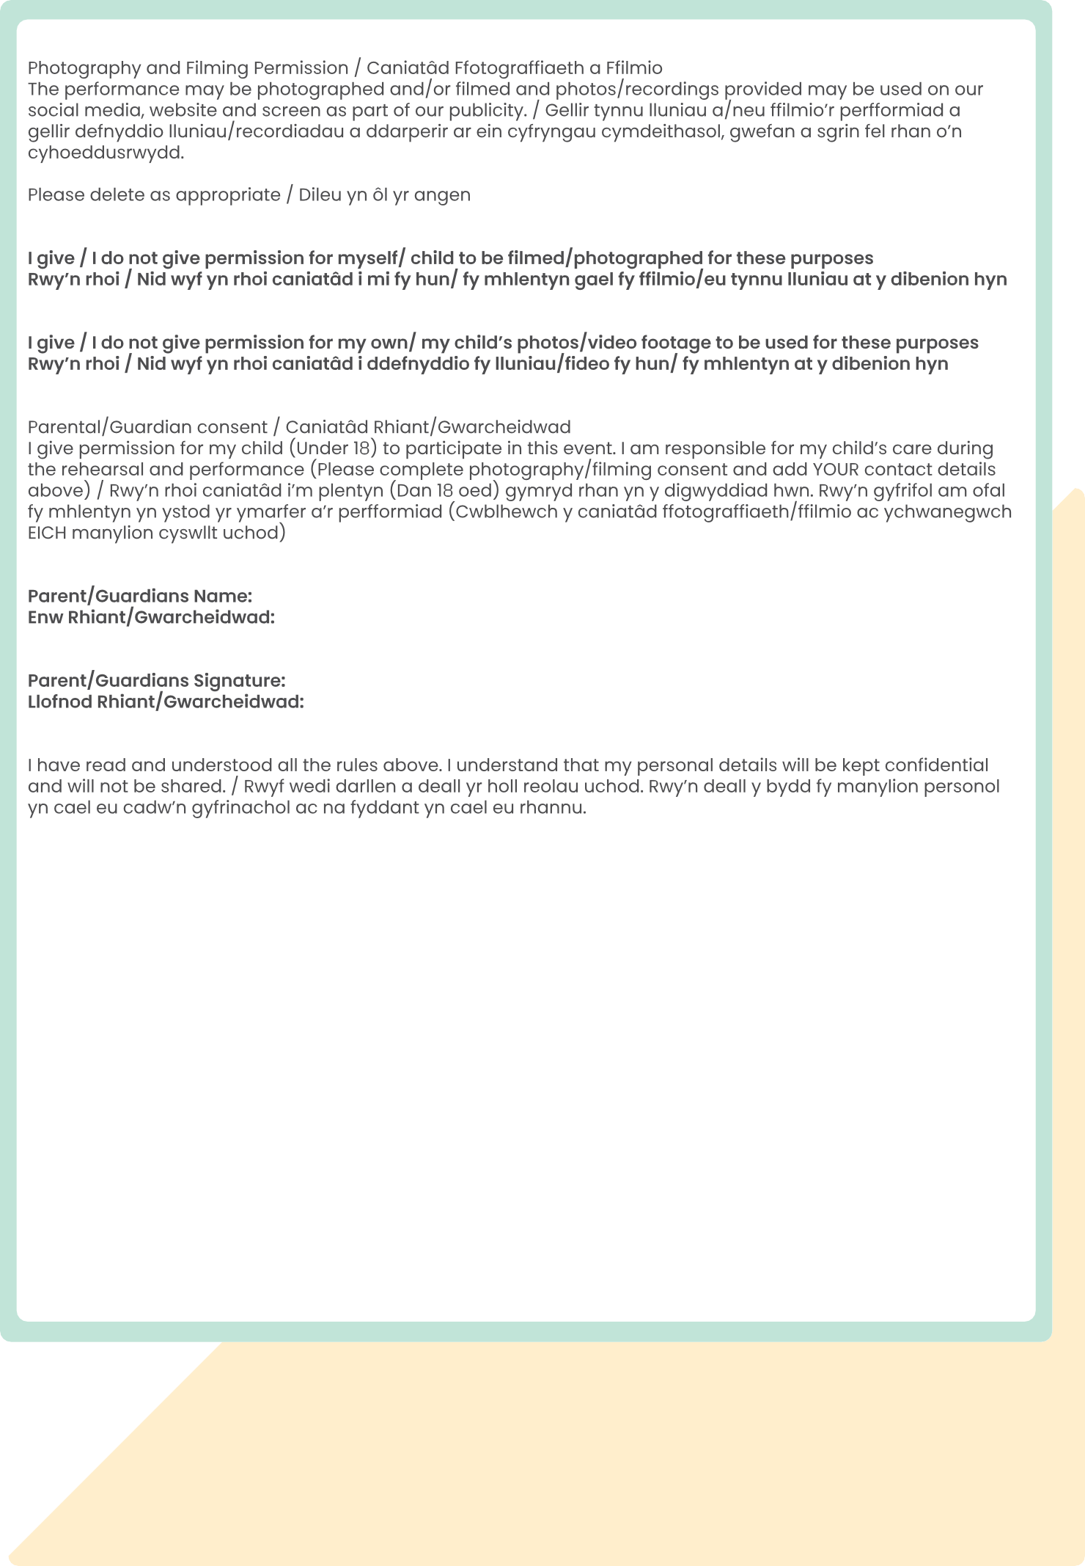

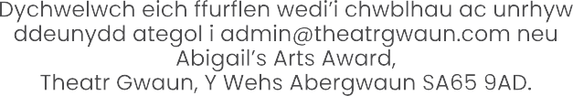



N
Y
Y
N
Signature here
Name here

