Name here

Address here

Postcode here

Email address here

Phone number here

Respond here

Respond here

Respond here

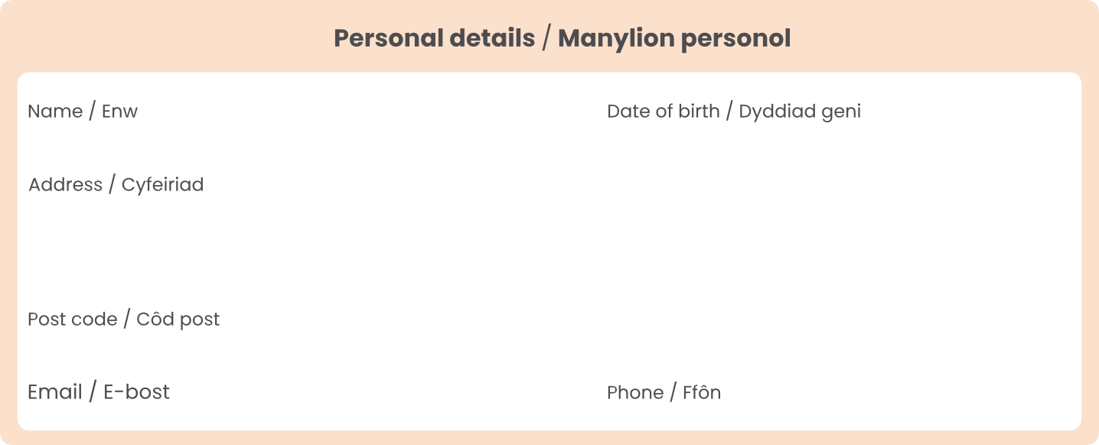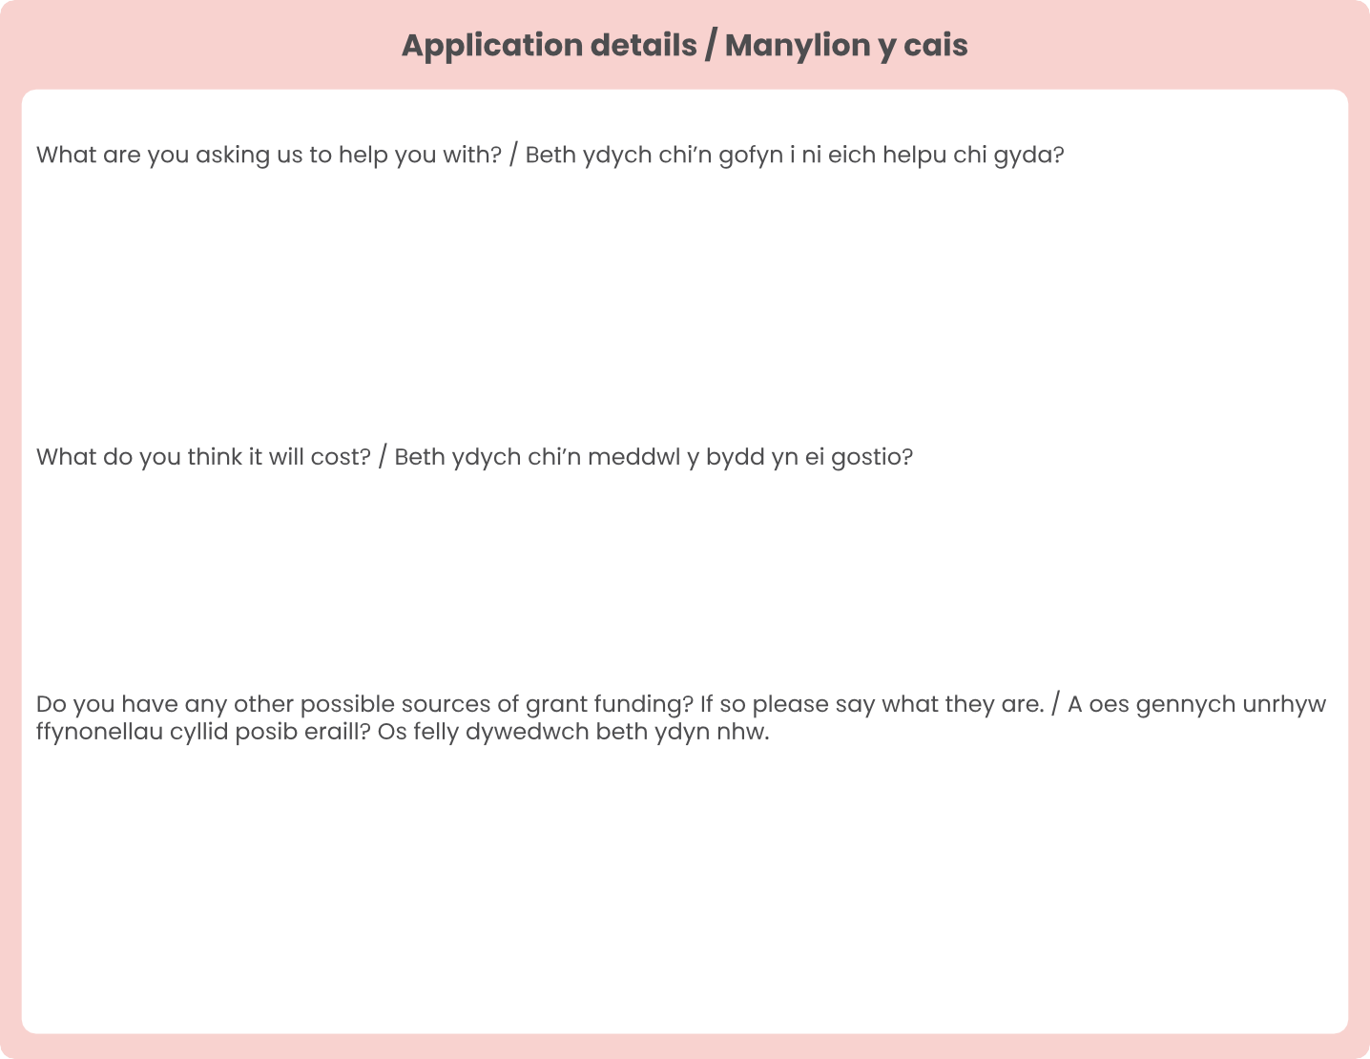

Date here



Respond here

Respond here

Respond here

Respond here



Respond here

Respond here

N

Y

Respond here

Respond here

Respond here

